[1]

An Extensible Induced Position Encoding Readout Method for Micro-pattern Gas Detectors

Shubin Liu, Qibin Xiang, Siyuan Ma, Zhongtao Shen, Guangyuan Yuan, Qi An

*Abstract*—The requirement of a large number of electronics channels has become an issue to the further applications of Micro-pattern Gas Detectors (MPGDs), and poses a big challenge for the integration, power consumption, cooling and cost. Induced position encoding readout technique provides an attractive way to significantly reduce the number of readout channels. In this paper, we present an extensible induced position encoding readout method for MPGDs. The method is demonstrated by the Eulerian path of graph theory. A standard encoding rule is provided, and a general formula of encoding & decoding for n channels is derived. Under the premise of such method, a one-dimensional induced position encoding readout prototyping board is designed on a 5×5 cm2 Thick Gas Electron Multiplier (THGEM), where 47 anode strips are read out by 15 encoded multiplexing channels. Verification tests are carried out on a 8 keV Cu X-ray source with 100μm slit. The [test](javascript:void(0);) results show a robust feasibility of the method, and have a good spatial resolution and linearity in its position response. The method can dramatically reduce the number of readout channels, and has potential to build large area detectors and can be easily adapted to other detectors like MPGDs.

*Index Terms*—micro-pattern gas detector, position encoding, multiplexing readout, tracking

# INTRODUCTION

O

ver the past 20 years, Micro-pattern Gas Detectors (MPGDs) are widely used in high-energy physics, and have expanded to astrophysics, nuclear physics and medical imaging.[1][2] The conventional readout techniques employ a large number of electronic channels, which poses a big challenge to the further applications of MPGDs. By changing the readout electrode’s structure and multiplexing the readout channels, an induced position encoding technique for micro-channel plate detector was developed by D. Kataria et al. [3] in 2007. The technique was used for MPGDs by R. Hu et al. in 2011 [4], where a preliminary feasibility test was implemented with Micromegas. This technique can significantly reduce the number of readout channels, but the foregoing works didn’t provide an extensible encoding method and the decoding is complicated. In this paper, an extensible induced position encoding readout method for MPGDs is presented. The method is demonstrated by the Eulerian path of graph theory. A standard encoding rule is provided, and a general formula of encoding & decoding for n channels is derived. A prototyping design is implemented on a 5×5 cm2 Thick GEM, and verification tests are carried out on a 8 keV Cu X-ray source with 100μm slit.

TABLE I

decoding table of 3 readout channels

|  |  |
| --- | --- |
| Channel: comparsion | Strip: position |
| CH1>CH2 | Strip 1 |
| CH2>CH3 | Strip 2 |
| CH3>CH1 | Strip 3 |
| CH1>CH3 | Strip 4 |
| CH3>CH2 | Strip 5 |
| CH2>CH1 | Strip 6 |

# Principle and method



Fig. . Induced position encoding readout schematic

## Principle

For ease of understanding, the simplified schematic is shown in Fig. 1. , where 6 strips are readout by 3 encoded multiplexing channels. Charge from detectors is collected by an anode strip and split across two induced strips which correspond to the respective readout channels. Due to the different width, charge is split unequally between the two induced strips, where the amplitude on one always higher than on the other. Based on the signal’s amplitude in corresponding channel, the hit position could be uniquely decoded as seen in Table I

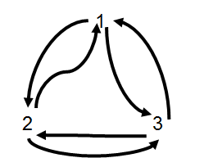

Fig. 2. An Eulerian Path

## Eulerian Path [Theorem](javascript:void(0);)

As shown in Fig. 1., 3 readout channels have $P_{3}^{2}$ ordered doublet combinations{12,23,31,13,32,21}which corresponds to 6 anode strips. The technique requires that any ordered doublet combination of channels appeared exactly once, and formed head to tail as an encoding list. Generally, the principle described above is a graph theory problem that whether there is an Eulerian path, where the doublet combinations represent the edges and the readout channels represent the vertices. Fig. 2. shows an Eulerian pathof the 3 readout channels in Fig. 1. According to Eulerian path theorem [5], it can be proved that there is an Eulerian path for n channels induced position encoding readout, as all of its vertices have an even degree. In other words, *n* channels can encode readout a maximum $P_{n}^{2}$ anode strips.

TABLE II

The encoding list of n readout channels

|  |  |  |  |  |  |  |  |  |  |  |  |
| --- | --- | --- | --- | --- | --- | --- | --- | --- | --- | --- | --- |
| Row | Encoding list | | | | | | | | | | |
| 1 | 12 | 21 |  |  |  |  |  |  |  |  |  |
| 2 | 13 | 32 | 23 | 31 |  |  |  |  |  |  |  |
| 3 | 14 | 42 | 24 | 43 | 34 | 41 |  |  |  |  |  |
| ... | … | … | … | … | … | … |  |  |  |  |  |
| k-1 | 1k | k2 | 2k | k3 | 3k | k4 | … | k(k-1) | (k-1)k | k1 |  |
| … | … | … | … | … | … | … | … | … | … | … |  |
| n-1 | 1n | n2 | 2n | n3 | 3n | n4 | … | … | n(n-1) | (n-1)n | n1 |

## Encoding and Decoding

It turns out that there are more than one constructions of Eulerian path. We need to make appropriate constraints to construct a regular and extensible encoding method so as to easily decode and design. As shown in Table 2, it is an extensible encoding list for n channels, where the list is organized in rows. The encoding form XY means that the signal’s amplitude of channel X is higher than channel Y’s.

According to the Table 2, the encoding formula (1) and decoding formula (2) can be derived as follows:

$${ （xy）}_{i}= \left\{ \begin{aligned} n,k R=1 \\ \left(k,\frac{R}{2}+k \right) i=even number \\ \left(\frac{R-1}{2}+k,k\right) i=odd number \end{aligned}\right.$$

(1)

$$i_{(x,y)}=\left\{ \begin{aligned}\left(y-1\right)\left(2n-y\right)+1 encoding form：ny \\ \left(y-1\right)\left(2n-y\right)+2\left(x-y\right)+1 encoding form： xy\left(x>y\right) \\ \left(x-1\right)\left(2n-x\right)+2\left(y-x\right) ending form：xy\left(x<y\right) \\ \end{aligned}\right.$$

(2)

# VERIFICATION TEST

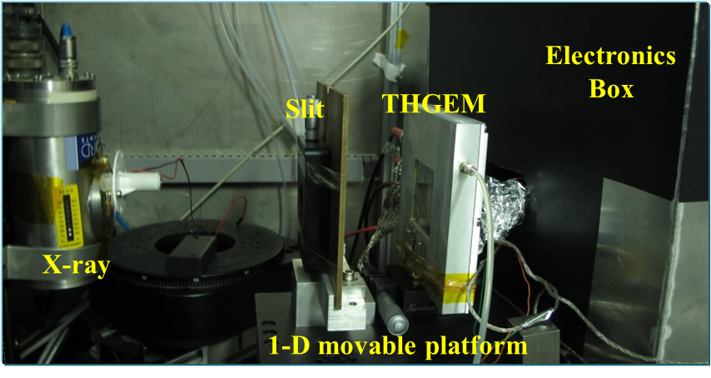

Fig. . Experimental setup

## Experiment for verification

In order to verify this method, a prototyping readout board was manufactured and equipped for a 5×5 cm2 THGEM detector[6]. To solve the case that each particle usually showers the signal on several neighboring strips, the neighboring strips are separated into three groups to encode respectively. Based on the encoding list shown in TALBE II, the prototyping board has 47 [one-dimensional](javascript:void(0);) 1.07mm strips which readout by 15 channels. According to the decoding formula, the hit strip can be decoded by the fired channels.

As shown in Fig.3. , verification tests were carried out on the THGEM detector using a 8 keV Cu X-ray and Ar/iC4H10 (97:3) gas mixture. A 100 μm [slit](javascript:void(0);) in a thin brass sheet was used to produce a miniaturized X-ray beam. A manual movable platform was used for the postion scanning test.The electronics is based on the VATA160 chip.[7]

## Result of tests

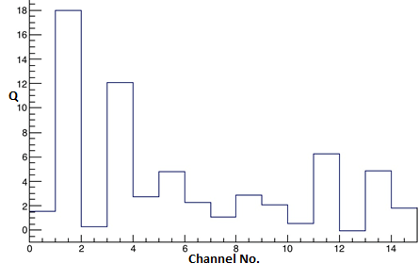

Fig. . The signal recorded on 15 channels when an event hit



Fig. . Spatial resolution result of the detector

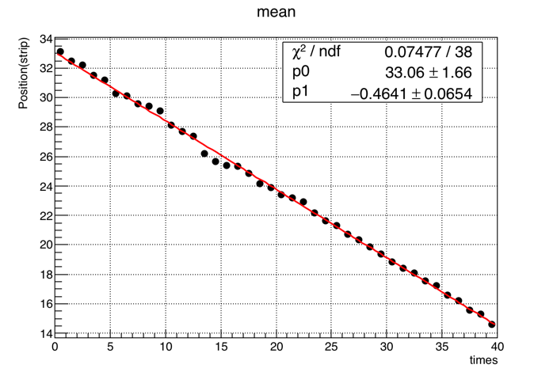

Fig. . Linear result of position scanning test

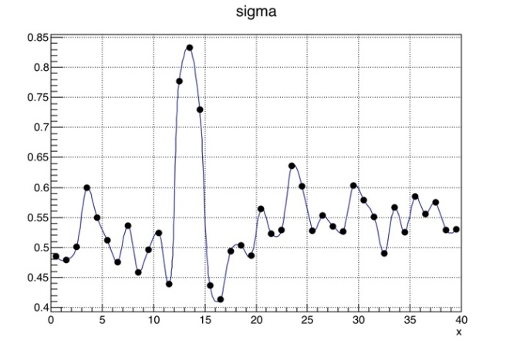

Fig. . Spatial resolution results of position scanning test

Fig. 4 shows the signals recorded on all 15 channels when an event hit. Considering the noise of electronics is about 7fC, the channel 2 and 4 are valid, and it can correctly to decode the hit position by the encoding form. Fig. 5 shows the decoded spatial resolution result of the detector is 0.4 strip (0.43mm). During the position scanning test, the detector was moved with a step size of 0.5 mm in a 20 mm range. Fig. 6 and Fig. 7 show the results of linearity and spatial resolution in the position scanning test.

# Conclusion

A novel method of encoded multiplexing readout for micro-pattern gas detectors is presented in this work. The method is demonstrated by the Eulerian path of graph theory. A standard rules for encoding is provided, and general formulas of encoding & decoding for n channels are derived. Under the premise of such rules, a one-dimensional position encoding readout circuit boards is designed based on a 5×5 cm2 THGEM，and a verification test is carried out on a 8 keV Cu X-ray source with 100μm slit. The test results indicate that the method can correctly decode the hit position, and have a good spatial resolution and linearity in its position response. The method provides an attractive way to significantly reduce the number of readout channels. Inevitably, the method has some [disadvantage](javascript:void(0);)s, such as lowering the signal to noise ratio (SNR) and lowering the detector’s rate capability.

References

*Basic format for books:*

1. Titov M. New developments and future perspectives of gaseous detectors[J]. Nuclear Instruments and Methods in Physics Research Section A: Accelerators, Spectrometers, Detectors and Associated Equipment, 2007, 581(1): 25-37.
2. Liu Q, Liu H B, Chen S, et al. A successful application of thinner-THGEMs[J]. Journal of Instrumentation, 2013, 8(11): C11008.
3. Kataria D O, Chaudery R, Rees K. High-speed position readout for microchannel plate-based space plasma instruments[J]. Nuclear Instruments and Methods in Physics Research Section A: Accelerators, Spectrometers, Detectors and Associated Equipment, 2007, 573(1): 240-242.
4. R. Hu,et al., Nuclear Physics Review, 2011, 28(4):459-463
5. Gross J L, Yellen J. Graph theory and its applications[M]. CRC press, 2005.
6. Liu H B, Liu Q, Chen S, et al. A study of thinner-THGEM, with some applications[J]. Journal of Instrumentation, 2012, 7(06): C06001.
7. VATA160 datasheet, IDEAS, Nydalen, Oslo, Norway, 2013. <http://www.ideas.no>

1. This paragraph of the first footnote will contain the date on which you submitted your paper for review. It will also contain support information, including sponsor and financial support acknowledgment. For example, “This work was supported in part by the U.S. Depart­ment of Com­merce under Grant BS123456”.

   The next few paragraphs should contain the authors’ current affiliations, including current address and e-mail. For example, F. A. Author is with the National Institute of Standards and Technology, Boulder, CO 80305 USA (e-mail: author@ boulder.nist.gov).

   S. B. Author, Jr., was with Rice University, Houston, TX 77005 USA. He is now with the Department of Physics, Colorado State University, Fort Collins, CO 80523 USA (e-mail: author@lamar.colostate.edu).

   T. C. Author is with the Electrical Engineering Department, University of Colorado, Boulder, CO 80309 USA, on leave from the National Research Institute for Metals, Tsukuba, Japan (e-mail: author@nrim.go.jp).